Name

Mathematics Stage 4
Data Classification

Book 1 | Classifying data | Version: 260915  Feedback:  https://MrDingMaths.com
Contents
Syllabus Content 2
Learning Intention 3

Syllabus Content
MA4-DAT-C-01 classifies and displays data using a variety of graphical representations
Classify data as either numerical (discrete or continuous) or categorical (nominal or ordinal) variables
- Define a variable in the context of statistics as any characteristic, number or quantity that can be measured or counted
- Classify and describe variables as numerical or categorical
- Describe a numerical variable as either discrete or continuous
- Describe a categorical variable as nominal or ordinal
- Distinguish between and compare numerical (discrete or continuous) and categorical (nominal or ordinal) variables

Classifying Data

- Variables
Data has variables and values.
- A variable is anything we can describe, measure, or count.
- Data values are the measurements.
Variables | Data Values
Age | 11, 12, 15, 21, 86
Grade | A, B, C, D, E
Colour | Red, Green, Orange

- Numerical and Categorical Variables
Categorical data is qualitative. It involves descriptions, categories, and names.
Numerical data is quantitative. It involves numbers.

- Classify variables as numerical or categorical
- The number of siblings you have | - Year 8’s favourite movie.
- Number of sheep in Australia. | - Favourite video game console.
- Favourite makeup brand. | - Time taken to complete a test.

- Discrete and Continuous Variables
- Numerical data can be discrete or continuous.
- Discrete data:
  - increase in steps.
usually comes from counting.
- Continuous data:
  - can have any value in a range.
usually comes from measuring.

- Classify variables as numerical discrete or numerical continuous
- Number of sheep in Australia. | - Time taken to complete a test.
- Mass of students’ schoolbags. | - Number of students late to school today.
- Number of people at a concert. | - Height of a year 9 student.

- Nominal and Ordinal Variables
- Categorical variables can be nominal or ordinal.
- Nominal data has no natural order, e.g. colours, flavours, locations etc.
- Ordinal data has a natural order, e.g. sizes, level of education, etc.

- Classify variables as categorical nominal or categorical ordinal
- Responses to a survey: disagree, neutral, agree | - Favourite colour of year 5 students.
- Survey of favourite ice cream flavours. | - Highest level of education achieved  (high school, diploma, university, PhD).
- Favourite travel destinations. | - Clothing sizes (small medium large)
- Classifying Data Summary
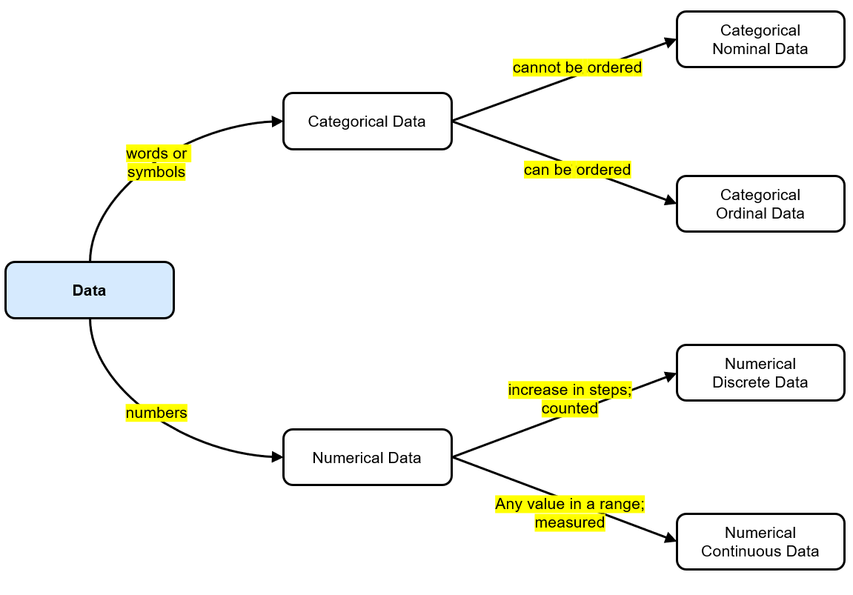

- Match each word to its definition
Numerical • | - Categorical data that has no order
Continuous • | - Data that are numbers
Discrete • | - Numerical data that take on a limited number of values
Categorical • | - Data that is not numbers.
Ordinal • | - Numerical data that take any value in a given range
Nominal • | - Categorical data that can be ordered

- Key Ideas
- Data is collected pieces of …………………………………
- A …………………… is anything that can be described, measured, or counted.
- There are two broad types of data: ……………………… and ………………………
- Numerical data can be ………………………… or ……………………
- Categorical data can be ………………………… or ……………………

Foundation
- Classify these variables as numerical (N) or categorical (C).
- Mass of student in kg N | C  N | - Brand of computers N | C  C
- Price of ice cream in $ N | C  N | - Number of TV sets N | C  owned by a family  N
- Amount of rainfall in mm N | C  N | - Cause of tooth decay N | C  C
- Sets won in a tennis match N | C  N | - Speed of truck in km/h N | C  N

- Classify these numerical variables as discrete (D) or continuous (C).
- Number of homes D | C  with solar power  D | - Amount of cough D | C  medicine taken by child  C
- Size of the crowd D | C  at a rock concert  D | - Number of road D | C  accidents in Grafton  D
- Times taken for D | C  athlete to run 100 metres  C | - Patients’ body temperature D | C  C
- School population D | C  D | - Seats on a bus D | C  D
- Mass of an athlete D | C  C | - Height of a building D | C  C

- Classify these categorical variables as nominal (N) or ordinal (O).
- Method of travel to work N | O  N | - Report grade N | O  O
- Suburb of home N | O  N | - Fan setting on air N | O  conditioner (low med high)  O
- Brand of car N | O  N | - Level of satisfaction N | O  with the government  O
- Olympic medal N | O  O | - Gender N | O  N
- Size of drink (small med large) N | O  O | - Favourite football team N | O  N

Development
- Which one of the following survey questions would generate numerical data?
- What is your favourite colour?
- What type of car does your family own?
- How long does it take for you to travel to school?
- What type of dog do you own?
C
- Which one of the following survey questions would generate categorical data?
- How many times do you eat at your favourite fast-food place in a typical week?
- How much do you usually spend buying your favourite fast food?
- How many items did you buy last time you went to your favourite fast-food place?
- Which is your favourite fast food?
D
- Classify the following as categorical or numerical, nominal, ordinal, discrete or continuous.
  - The heights of members of a football team.
Numerical continuous
  - The distance to drive to the train station.
Numerical continuous
  - The different types of ice creams.
Categorical nominal
  - The quality of food in a restaurant (bad, ok, great).
Categorical ordinal
  - The eye colour of a group of people.
Categorical nominal
  - Size of a drink at McDonald’s (small, medium, large).
Categorical ordinal
  - The number of pets in a household.
Numerical discrete
  - The time to swim 50 metres.
Numerical continuous
  - The number of goals scored in a season.
Numerical discrete
  - Today’s most fashionable style of dress.
Categorical nominal
  - The number of computers in the building.
Numerical discrete
  - Replies given to a questionnaire (yes, maybe, no).
Categorical ordinal
  - The perimeter of a block of land.
Numerical continuous
  - The width of the Anzac Bridge.
Numerical continuous
  - The number of people killed on the roads.
Numerical discrete
  - The distance travelled by a car in 30 minutes.
Numerical continuous
  - The most popular brand of car.
Categorical nominal
  - Daily temperature of a lake.
Numerical continuous
  - Time taken to solve a Rubik’s Cube.
Numerical continuous
  - Log of how many push ups done in a day.
Numerical discrete

- A marketing poll was conducted that asked about a person’s employment status:
unemployed, receiving education, part-time job or full-time job
Classify the type of data that would result from this poll

Categorical ordinal
- Emma is planning to build a new restaurant. She conducted a survey of the community.
One of the questions asked was ‘How far in kilometres would you be prepared to travel to get to a good restaurant?’ The options given were:
5 km, 10 km, 15 km, 20 km
Classify the type of data that would result from this poll

Numerical discrete
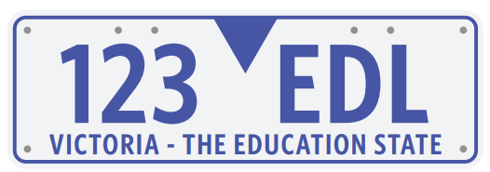
- Freddy says that number plates represent categorical ordinal data because numbers and letters have a natural order. Explain why he is incorrect.

Letters and numbers have a natural order, but license plates are random, so there is no random order. Categorial nominal.
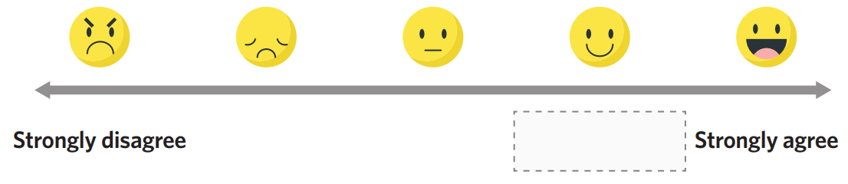
- A ​Likert​ scale ​is ​often​ used​ to ​measure ​attitudes​ and ​opinions.​ A​ version​ of​ it​ is​ shown​ below​ visually,​ as well as on a spectrum.

  - What type of data does a Likert Scale collect?
Categorical ordinal
  - What would be the most appropriate to fill in the blank space?

agree

  - Area is recorded in square metres. Classify this data.
Numerical continuous
  - Area is recorded in whole number of football fields. Classify this data.
Numerical discrete

Mastery
- 2015 HSC Standard 2 Band 4
On a school report, a student’s record of completing homework is graded using the following codes.
C = consistently
U = usually
S = sometimes
R = rarely
N = never
What type of data is this?

Categorial ordinal
- 2018 HSC Standard 2 Band 4
A survey asked the following question. 'How many brothers do you have?'
How would the responses be classified?

Numerical discrete
- 2021 HSC Standard 2 Band 5
Which of the following would provide data that are both categorical and nominal?
- Hair colour
- Height in centimetres
- Number of people at a concert
- Size of coffee cup classified as small, medium, large
A

- 2016 HSC Standard 2 Band 6
Which set of data is classified as categorical and nominal?
- Blue, green, yellow
- Small, medium, large
- cm, 6 cm, 7.21 cm
- 4 people, 5 people, 6 people
A

- Collections of data can be described as numerical or categorical depending on the responses. Classify the data as categorical or numerical collected from these responses:
- Question: “What size is your shoe?”  Responses: Small, Medium, Large  Categorical ordinal | - Question: “What size is your shoe?”  Responses: 20 cm, 21 cm, 22 cm …  Numerical discrete
- Question: “How much homework do you do per week?”  Responses: none to lots  Categorical ordinal | - Question: “How much homework do you do per week?”  Responses: whole number of hours  Numerical discrete

- Zach says, “Age is an example of discrete data." Ed says, "Age is continuous data."
Suggest why each person thinks what they do.

Discrete if we just say the year, continuous if we measure to the day, hour, second, millisecond, etc.
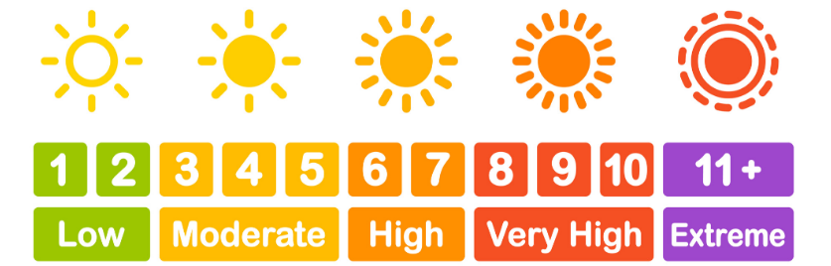
- Consider the UV index:
When would the UV index be numerical?
When using the top number scale
When would the UV index be categorical?
When using the bottom descriptive scale

- Mr Ding is quite fond of the FM radio station 101.7. He decides to collect data on the favourite radio station of the other teachers. He says: “I am collecting numerical data, since radio stations are numbers.” Explain why his incorrect.

Radio stations are not counted or measured, so it is categorical
- Many people argue that if something is not counted nor measured, it is categorical data.
Shoe size (8, 9, 10, etc.) would then be classified as categorical ordinal data, rather than numerical discrete.
Classify the following data as categorical or numerical, using this new definition.
  - The number rolled on a die.
  - Restaurant star rating.
  - Electrical appliance energy star rating.
  - UV index.
All categorical ordinal

